Project - 1

- Object Creation: Here, your task is to create objects for the flow.
A. Create custom object named:
a. Course
b. Subjects
c. Course Leads
d. Technology
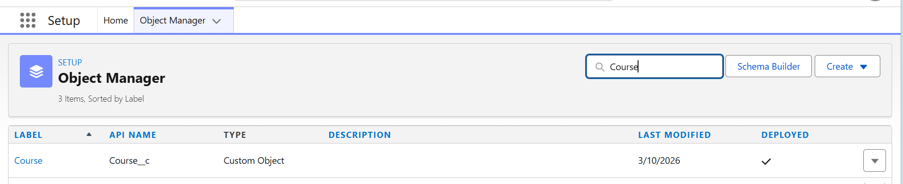
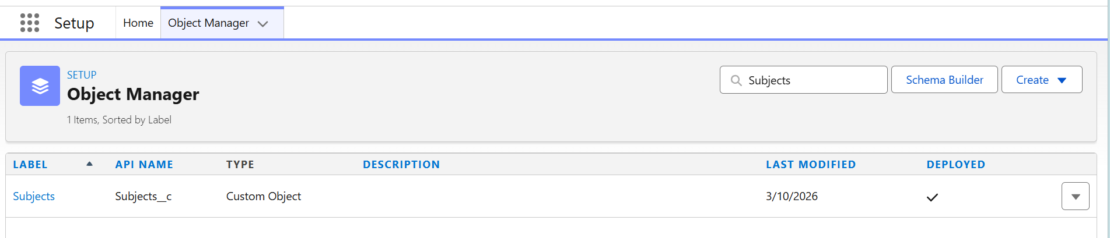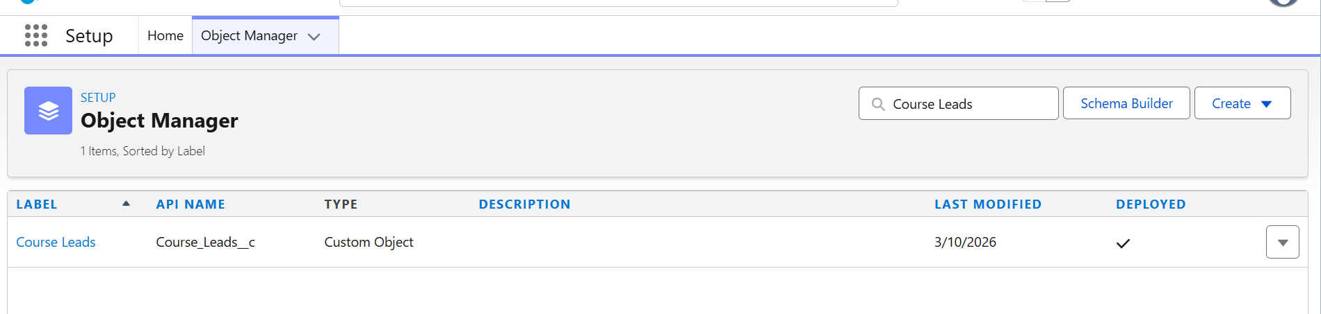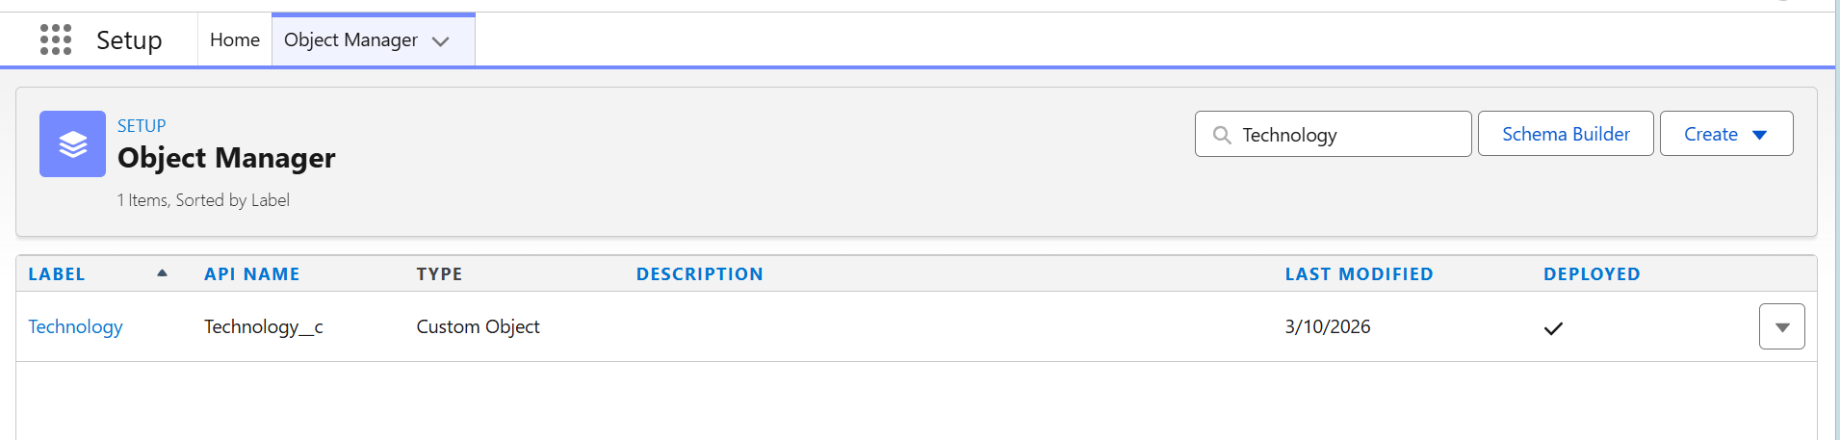
2. Field Creation: Here, your task is to create fields related to all the objects created in the 1st part of the tasks.
A. Course:
a. Course Name
b. No. of Modules
c. Course Duration
d. Rating
e. Active
f. Instructor Name
g. Type of Course
h. Priority
i. Start Date
j. End Date
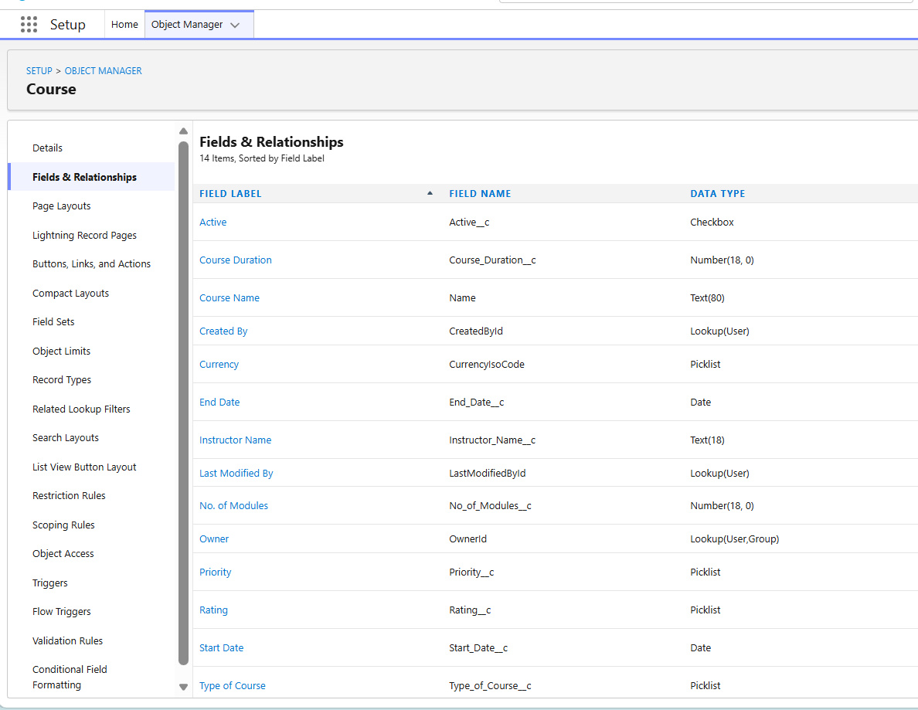
B. Subject:
a. Subject Name
b. No. of Modules
c. Instructor Name
d. Rating
e. Priority
f. Category
g. Level
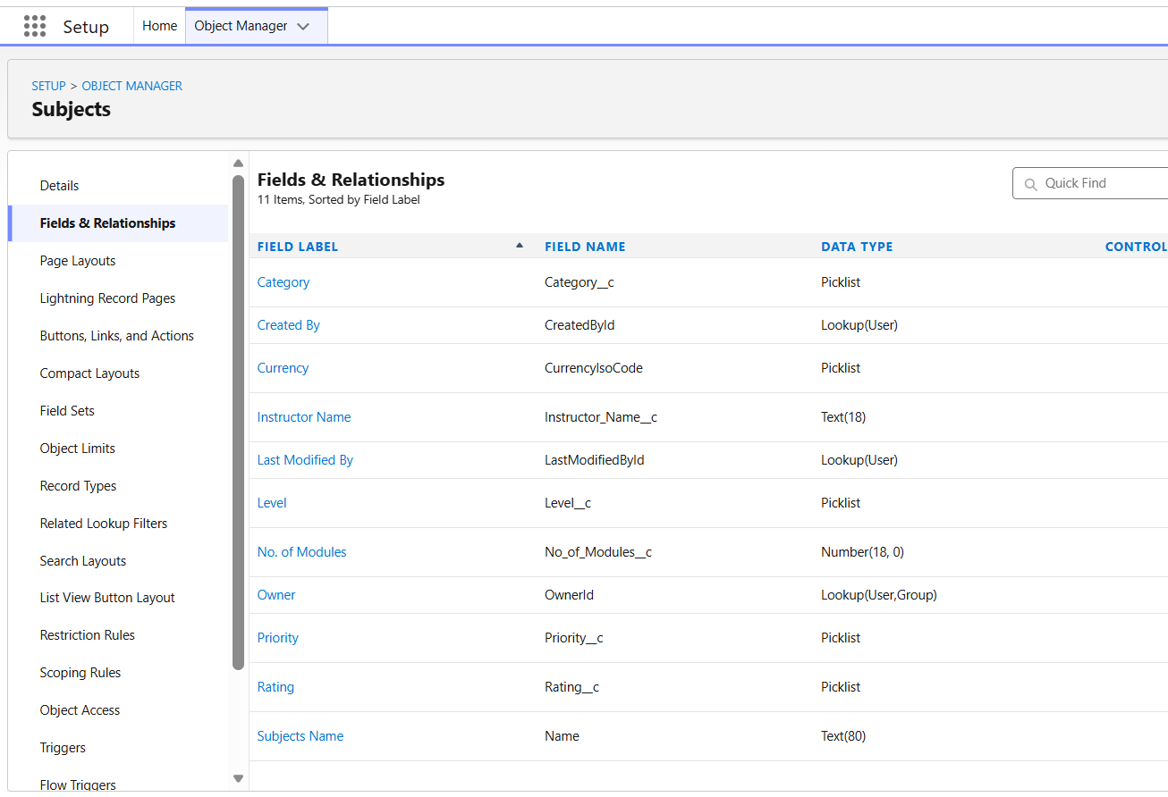
C. Course Leads:
a. First Name
b. Last Name
c. Phone
d. Email
e. Source
f. Category
g. Rating
h. Currency
i. Course Lead Amount
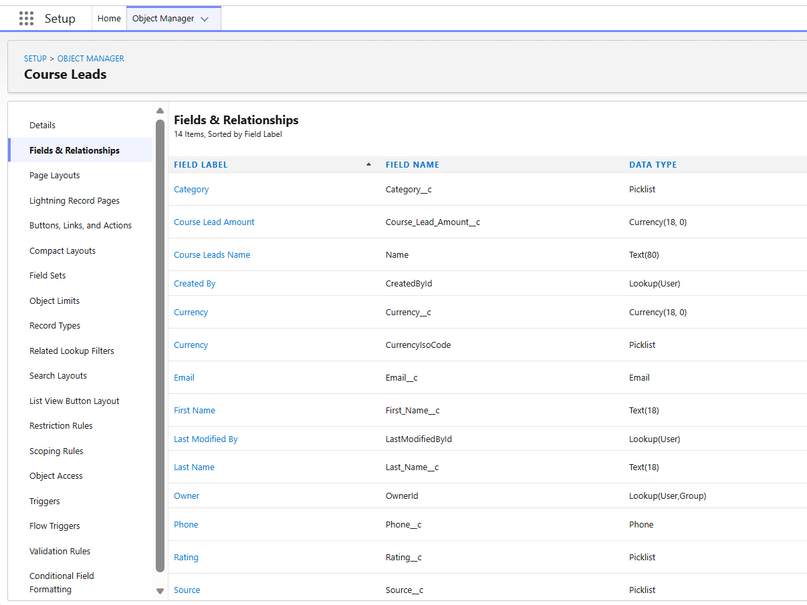
D. Technology
a. Name
b. Type
c. Category
d. Rating
e. Active
f. Instructor Name
i. Mobile
ii. Email
iii. Qualification
iv. Availability

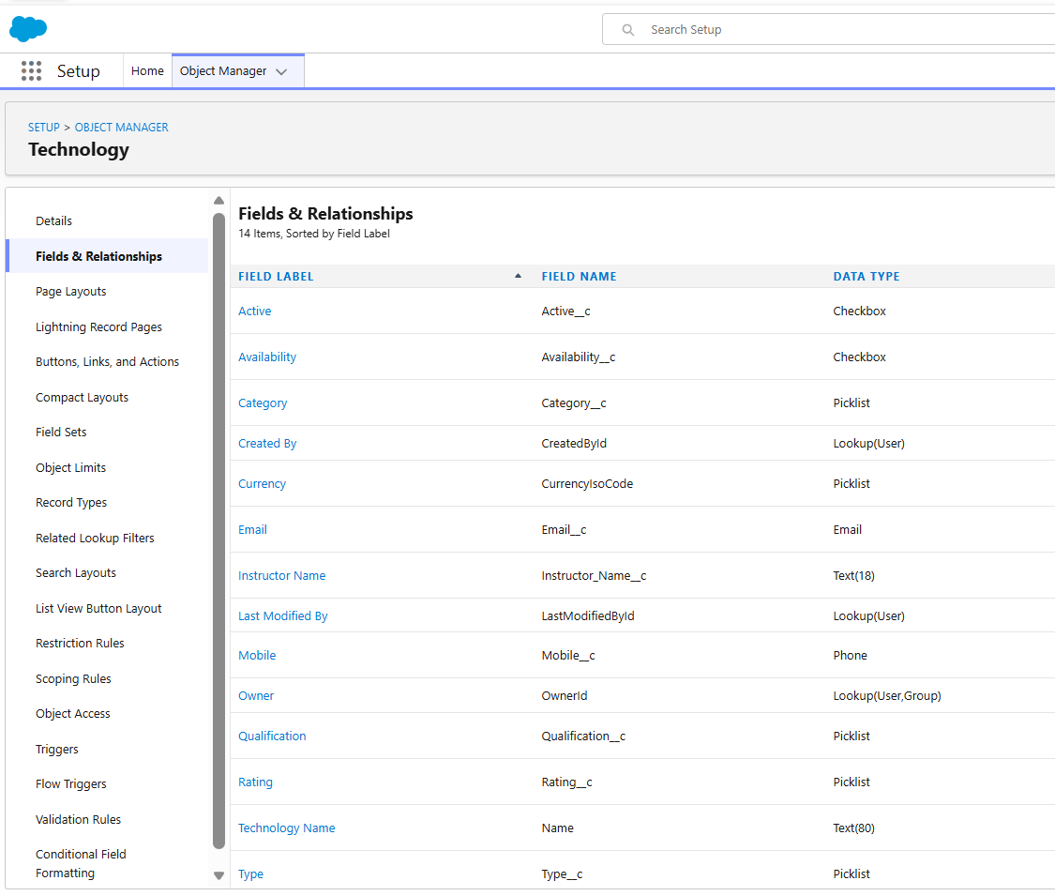

3. Add Validation Rules for verifying data:
a. Add validation rule for every field to verify that the fields are not empty for the objects:
● Course
● Subjects
● Course Leads
● Technology

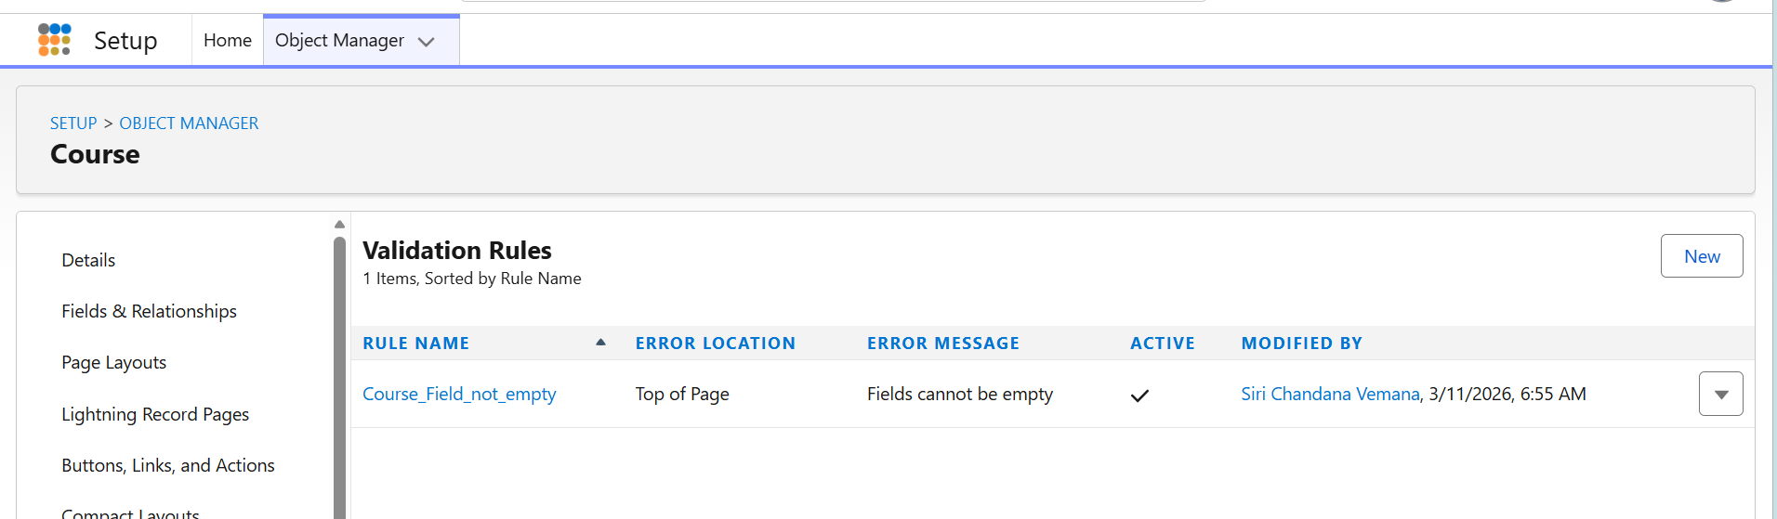

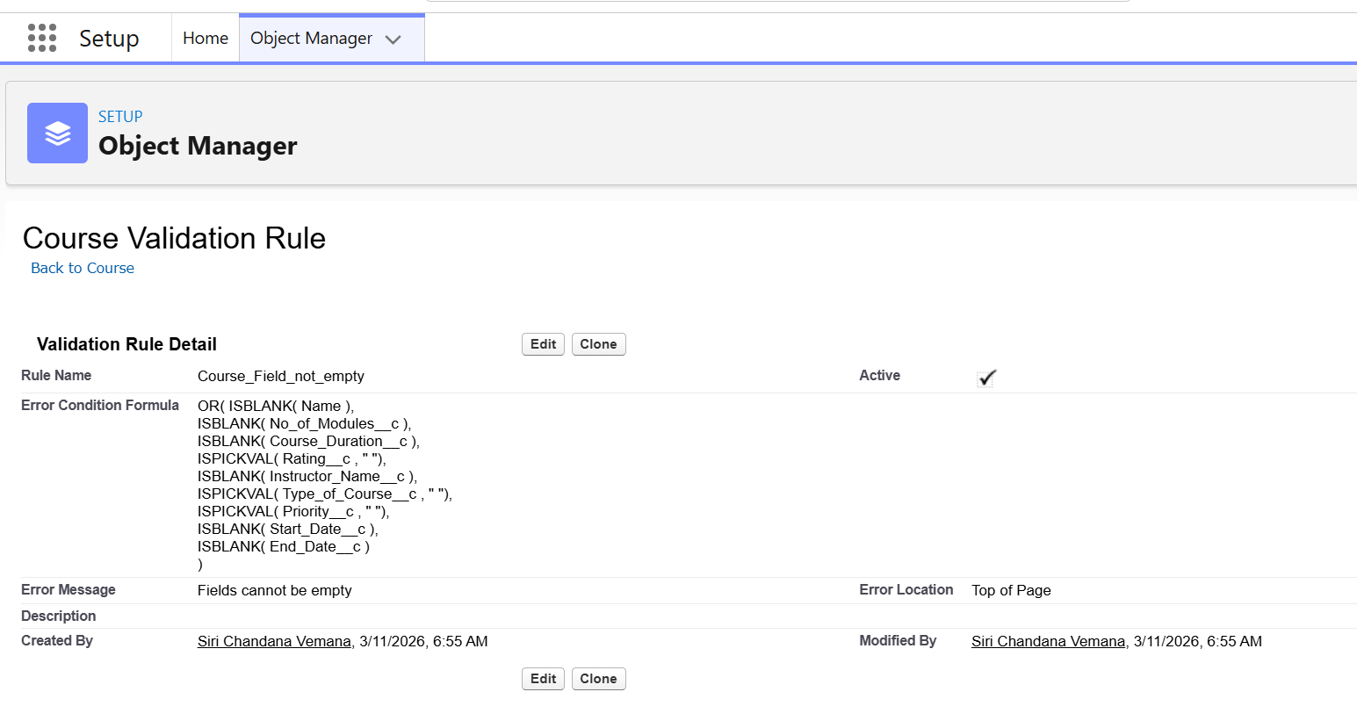
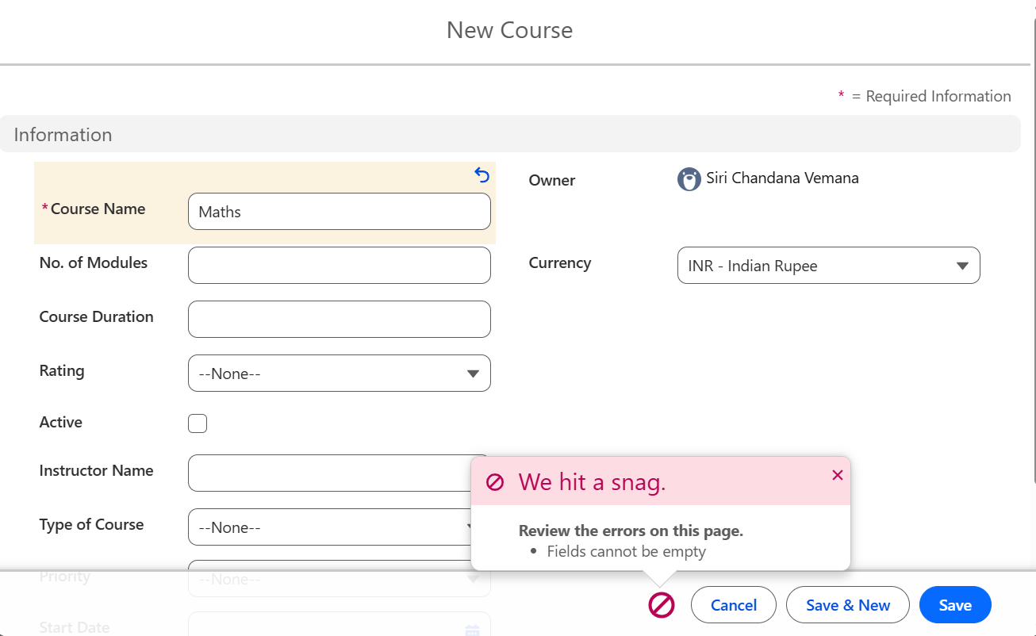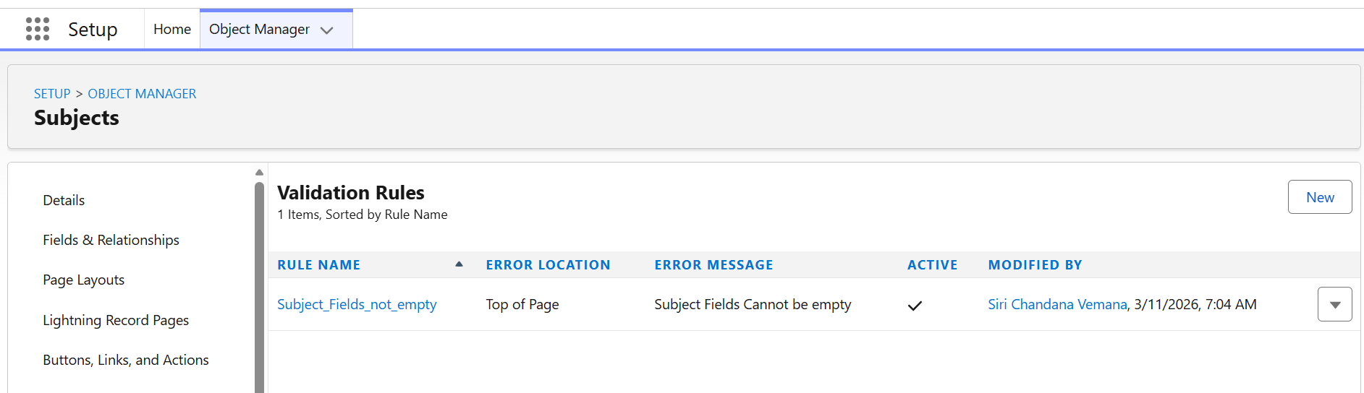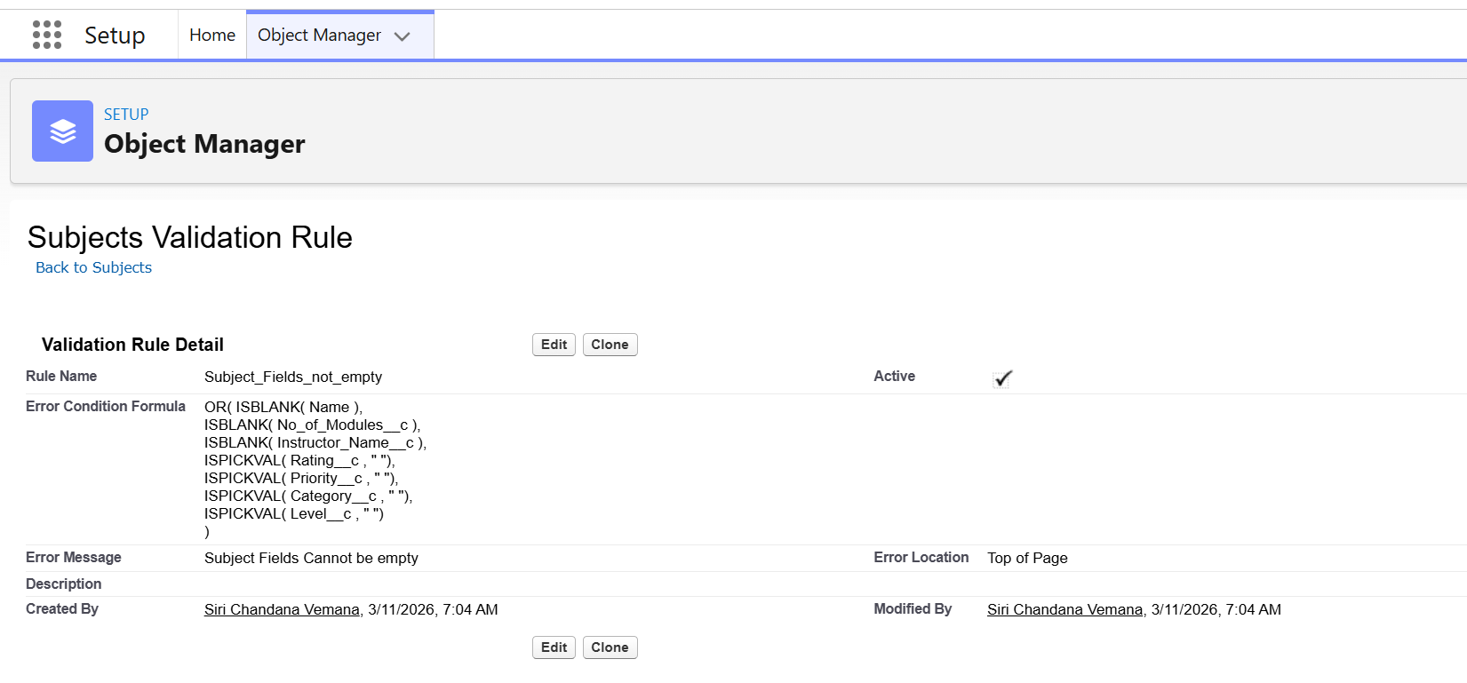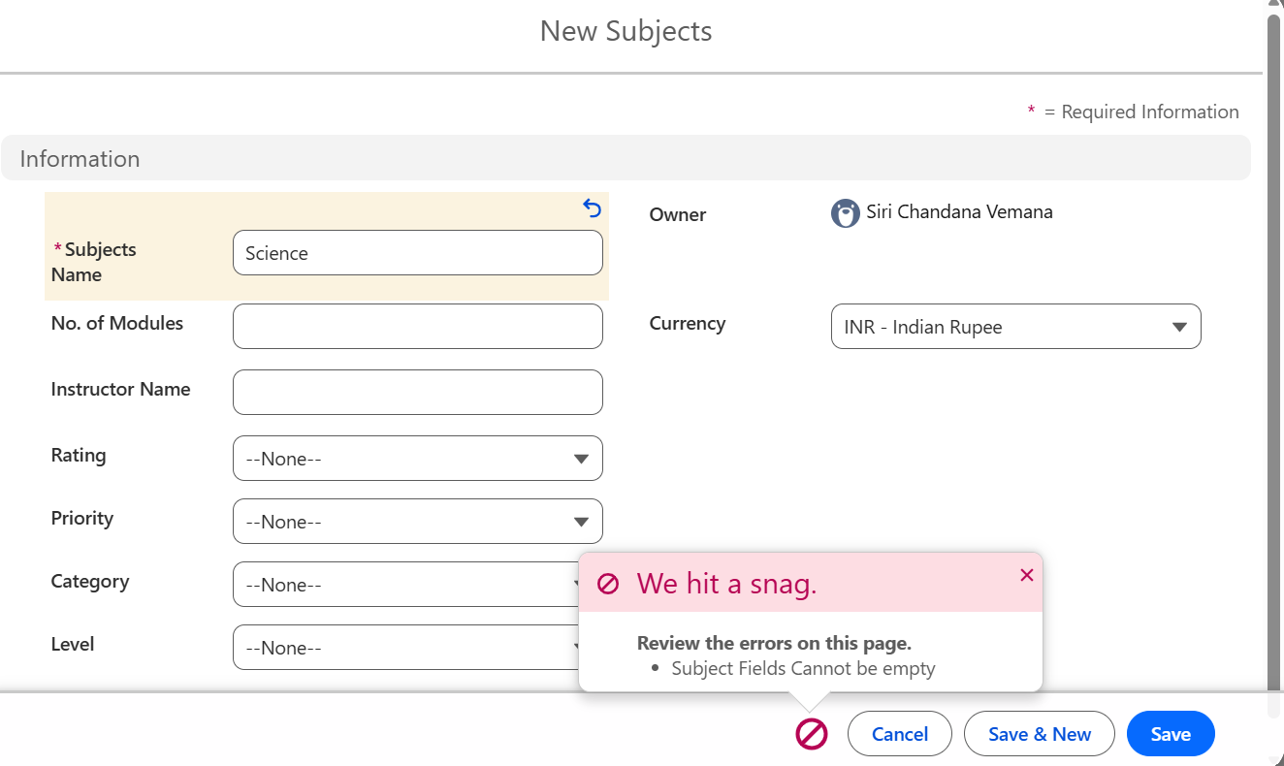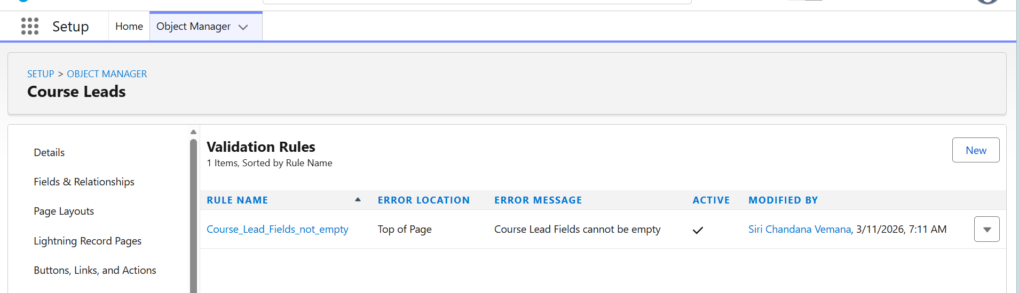
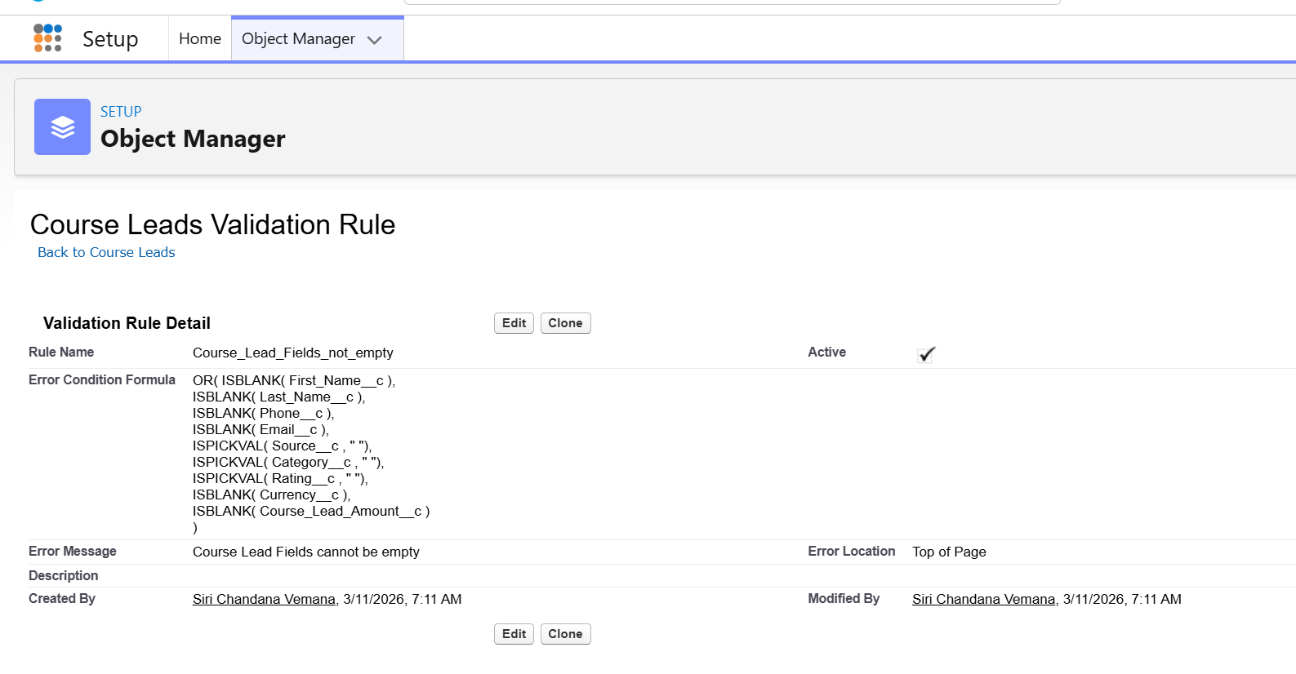
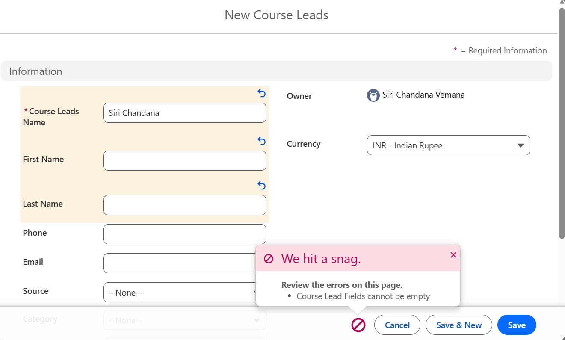
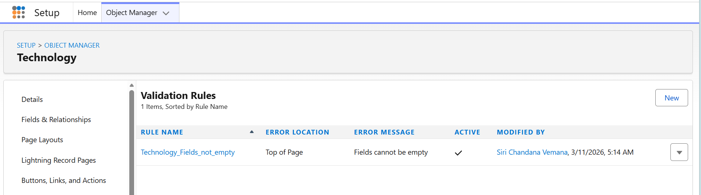

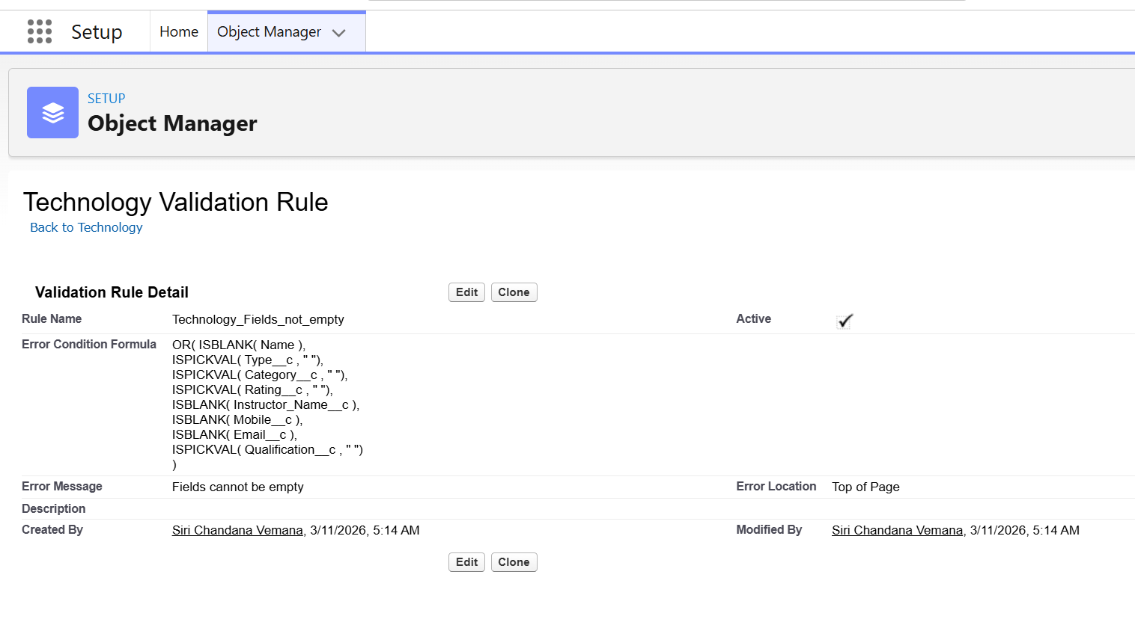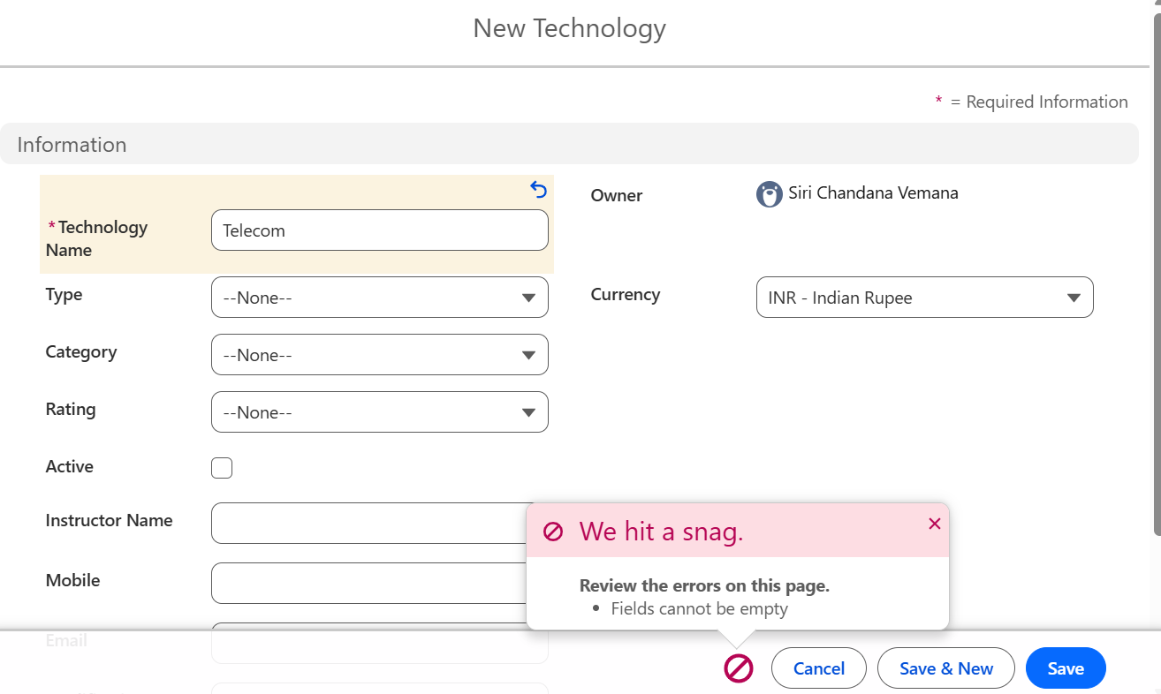
4. Set Workflow rules for all the custom objects created.
a. The workflow rules should be created in such a way that it should update the data after the following criteria is met:
● If the priority of course is high, then update the course name to ‘High Priority’+ Course Name.
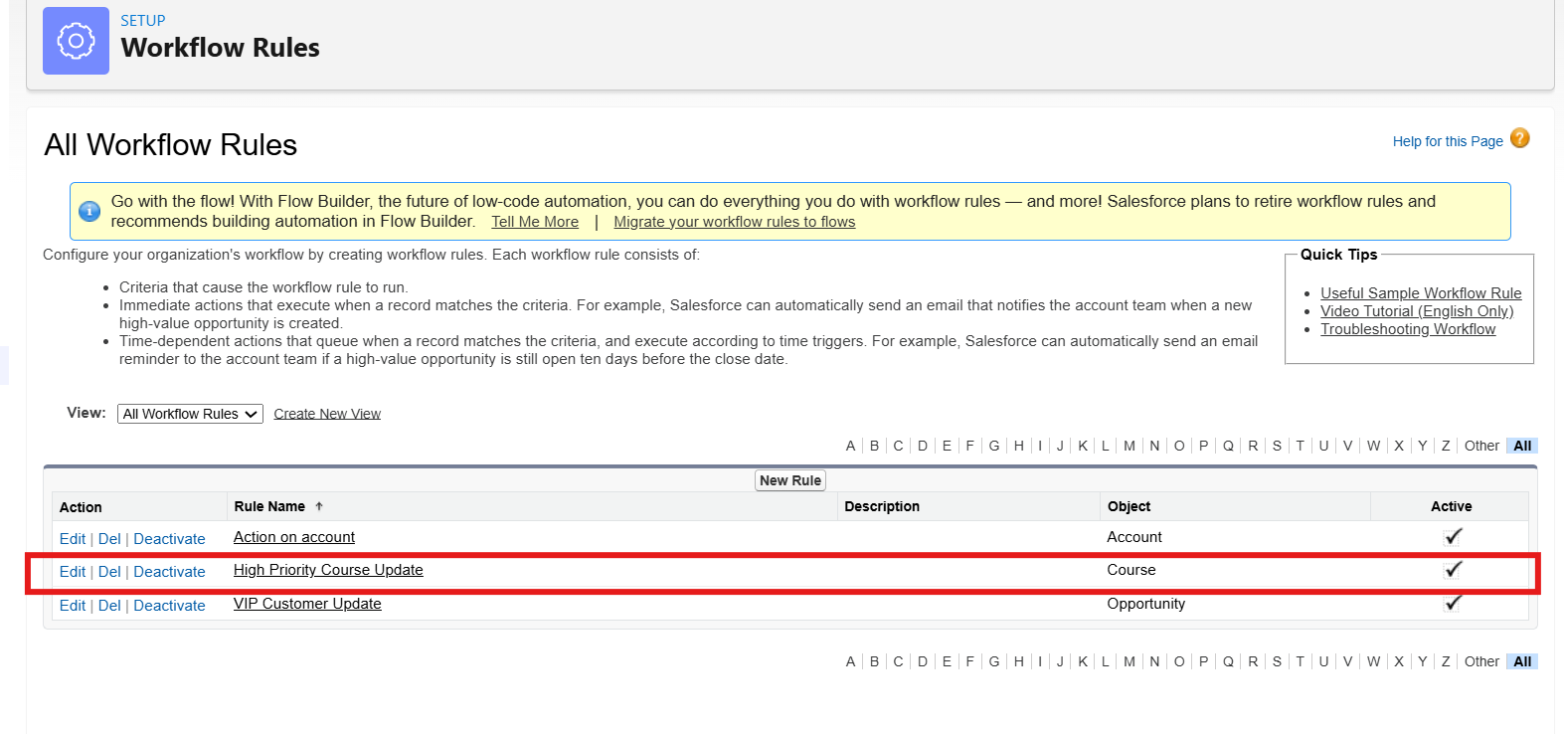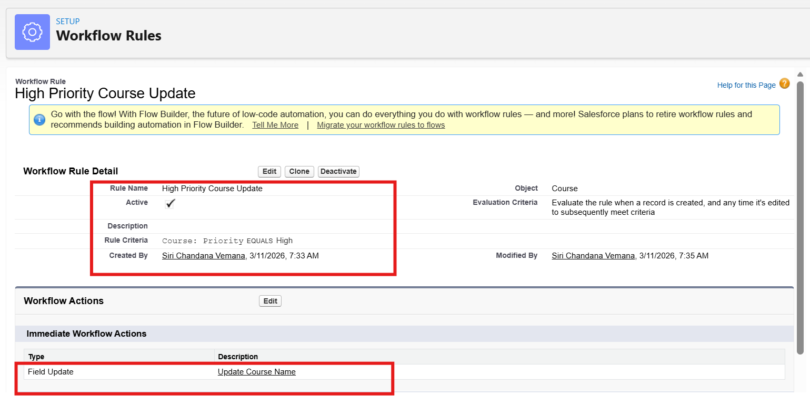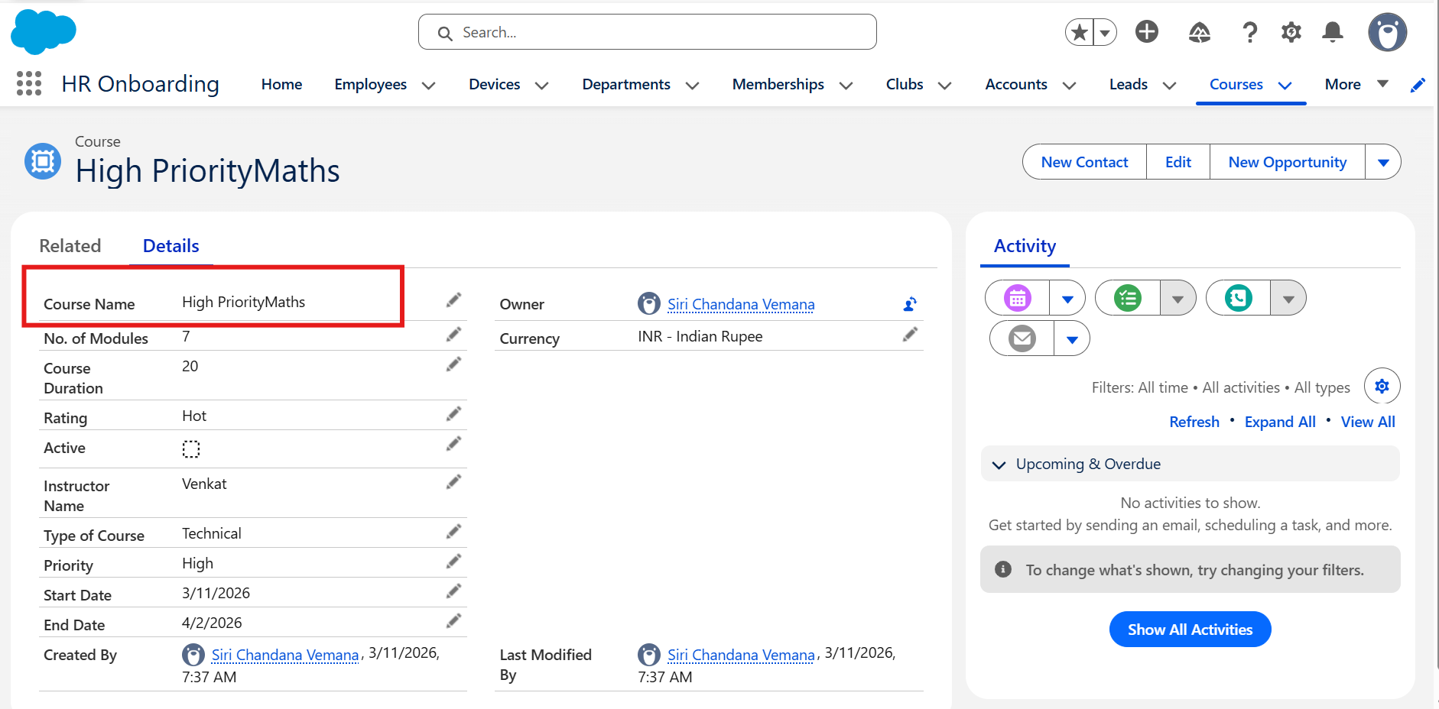
● If the course lead amount is greater than USD $1000 then update the name field to ‘Top Priority Customer’+ Name.
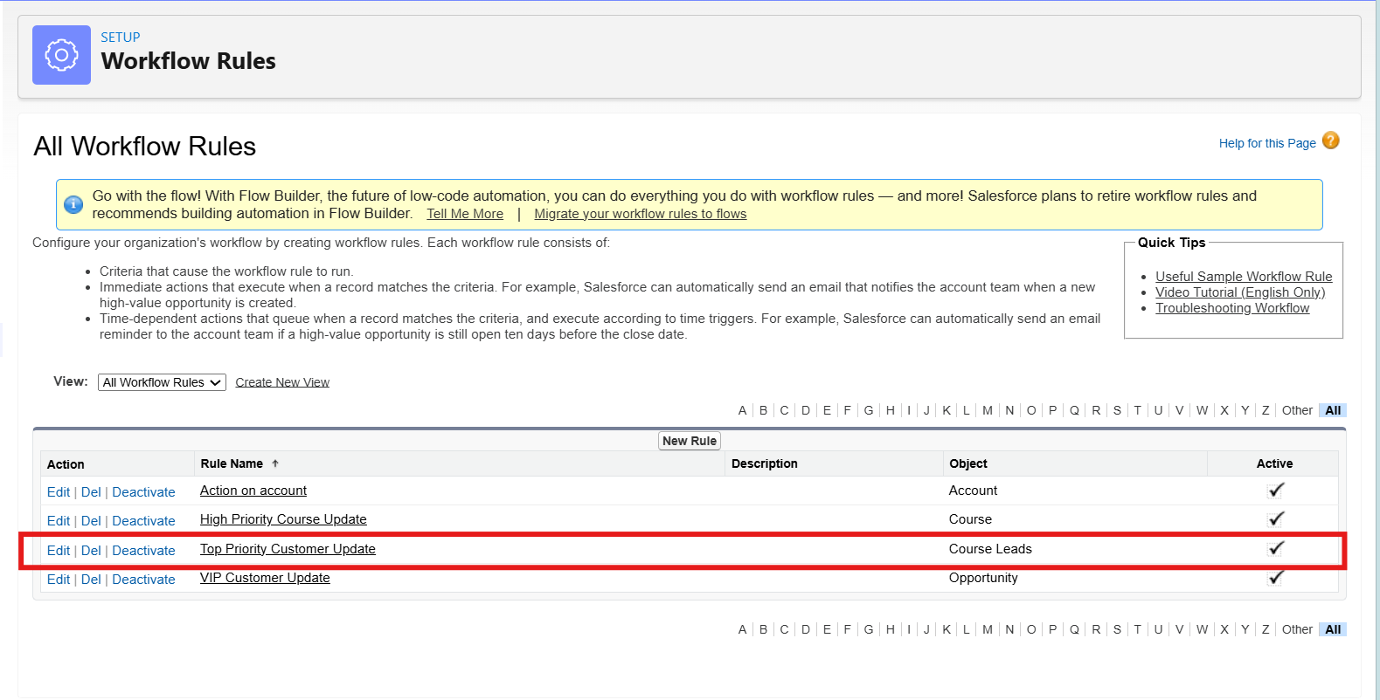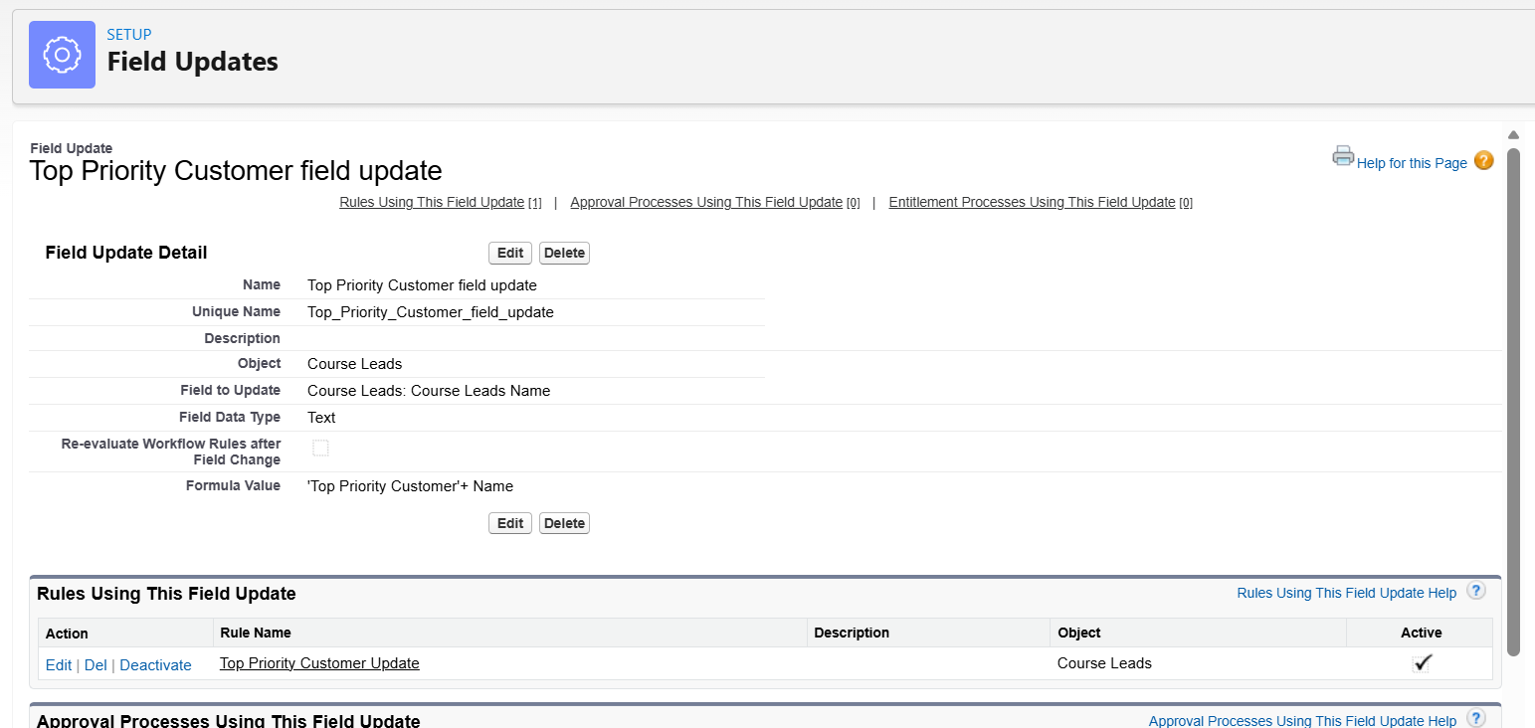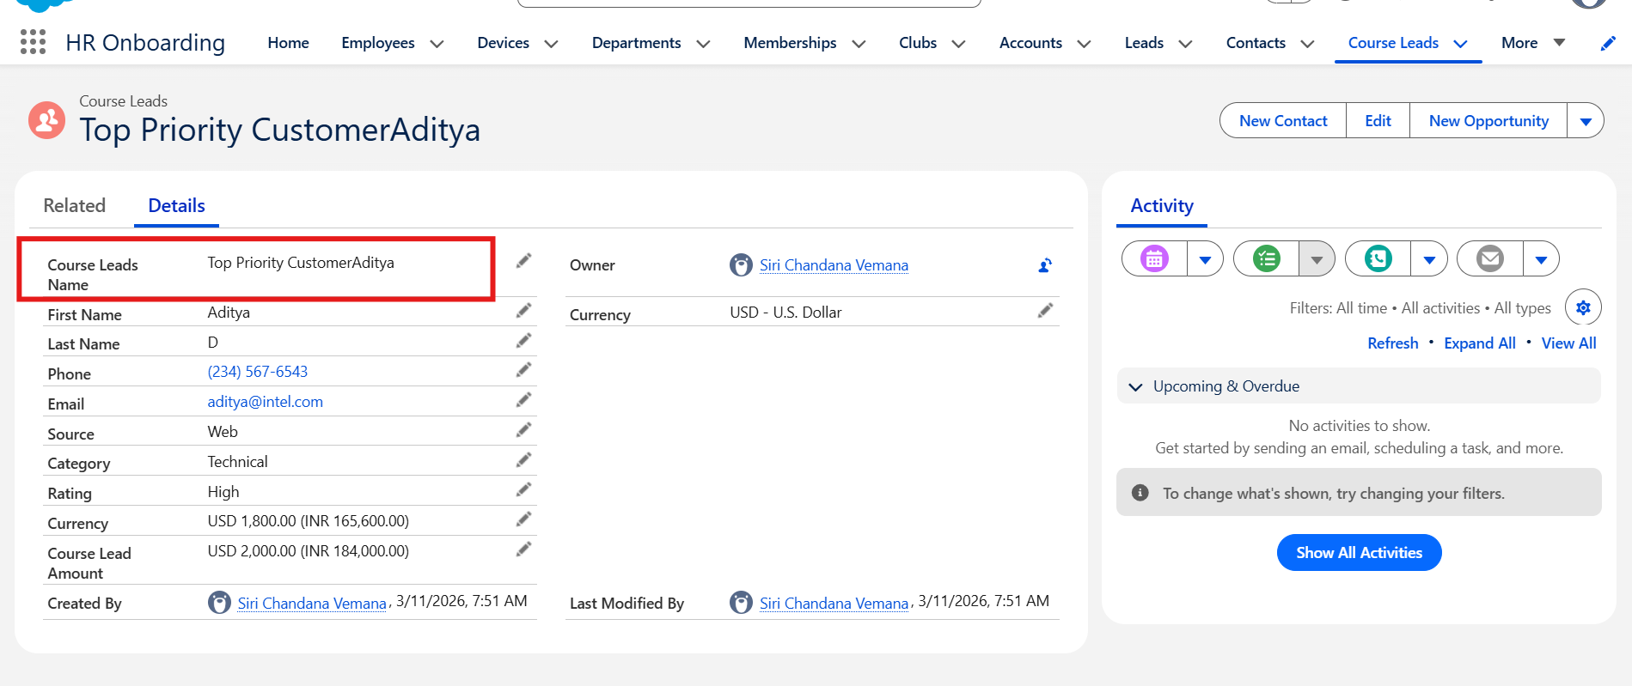
5. Create a flow using the below scenario for creating a Case.
a. First, the user should enter the following fields in the case:
● Name
● Phone
● Email
● Course Enrolled
● Subject
● Instructor Name
● Query Description
After the case is created, assign the case to the course instructor. If the instructor is unavailable, assign it to a specific executive of the company. Further, when the query is resolved, update the Case as ‘Resolved’.
